Families will be judged by the following guidelines:

- Machine completes the task within the 2 minute time limit
  - First attempt (40 pts)
  - Second attempt (30 pts)
  - Third attempt (20 pts)
- Machine uses creative steps to complete the task
  - 5 pts per step

In the event of a tie, the family who completes the task closest to the 2 minute time limit will be considered the winner.

Will your family be the first one to take home the Family Challenge Trophy?

Georgetown Homeschool Group 2015 Expo

Rube Goldberg Family Challenge

Rube Goldberg Family Challenge

“Rube Goldberg (1883-1970) was a Pulitzer Prize winning cartoonist, sculptor and author. …Best known for his “inventions”, Rube’s early years as an engineer informed his most acclaimed work. A Rube Goldberg contraption – an elaborate set of arms, wheels, gears, handles, cups and rods, put in motion by balls, canary cages, pails, boots, bathtubs, paddles and live animals – takes a simple task and makes it extraordinarily complicated.” - www.rubegoldberg.com

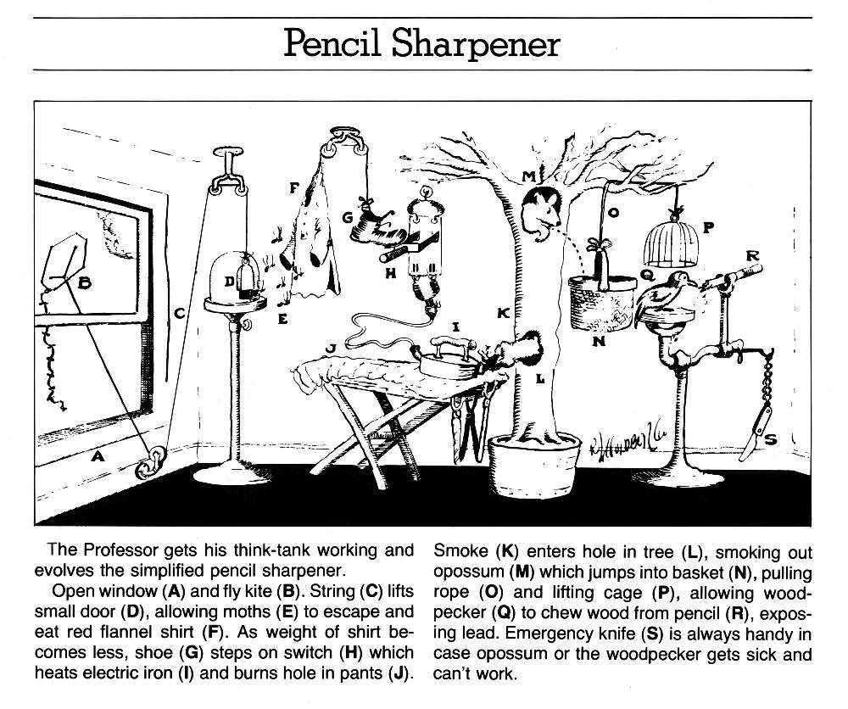

“Cut The Cheese”

Rules for Family Challenge:
- One Rube Goldberg machine per family
- Machine must completely cut through one plane of an 8oz. block of cheddar cheese, measuring approximately 2 ½“x1”x5 ½”
- Time limit to complete challenge = 2 minutes (once machine is started)
- Machine must fit inside a 4’x4’ footprint
- Machine height must not exceed 8’
- No hazardous materials, explosives, or flames
- Must be safe for participants and observers
- Machine may be reset 3 times with each reset not to exceed 2 minutes
- Family must provide their own cheese

